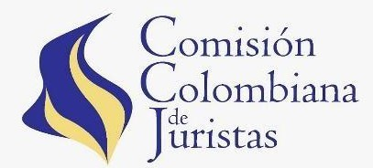Book Launch & Discussion

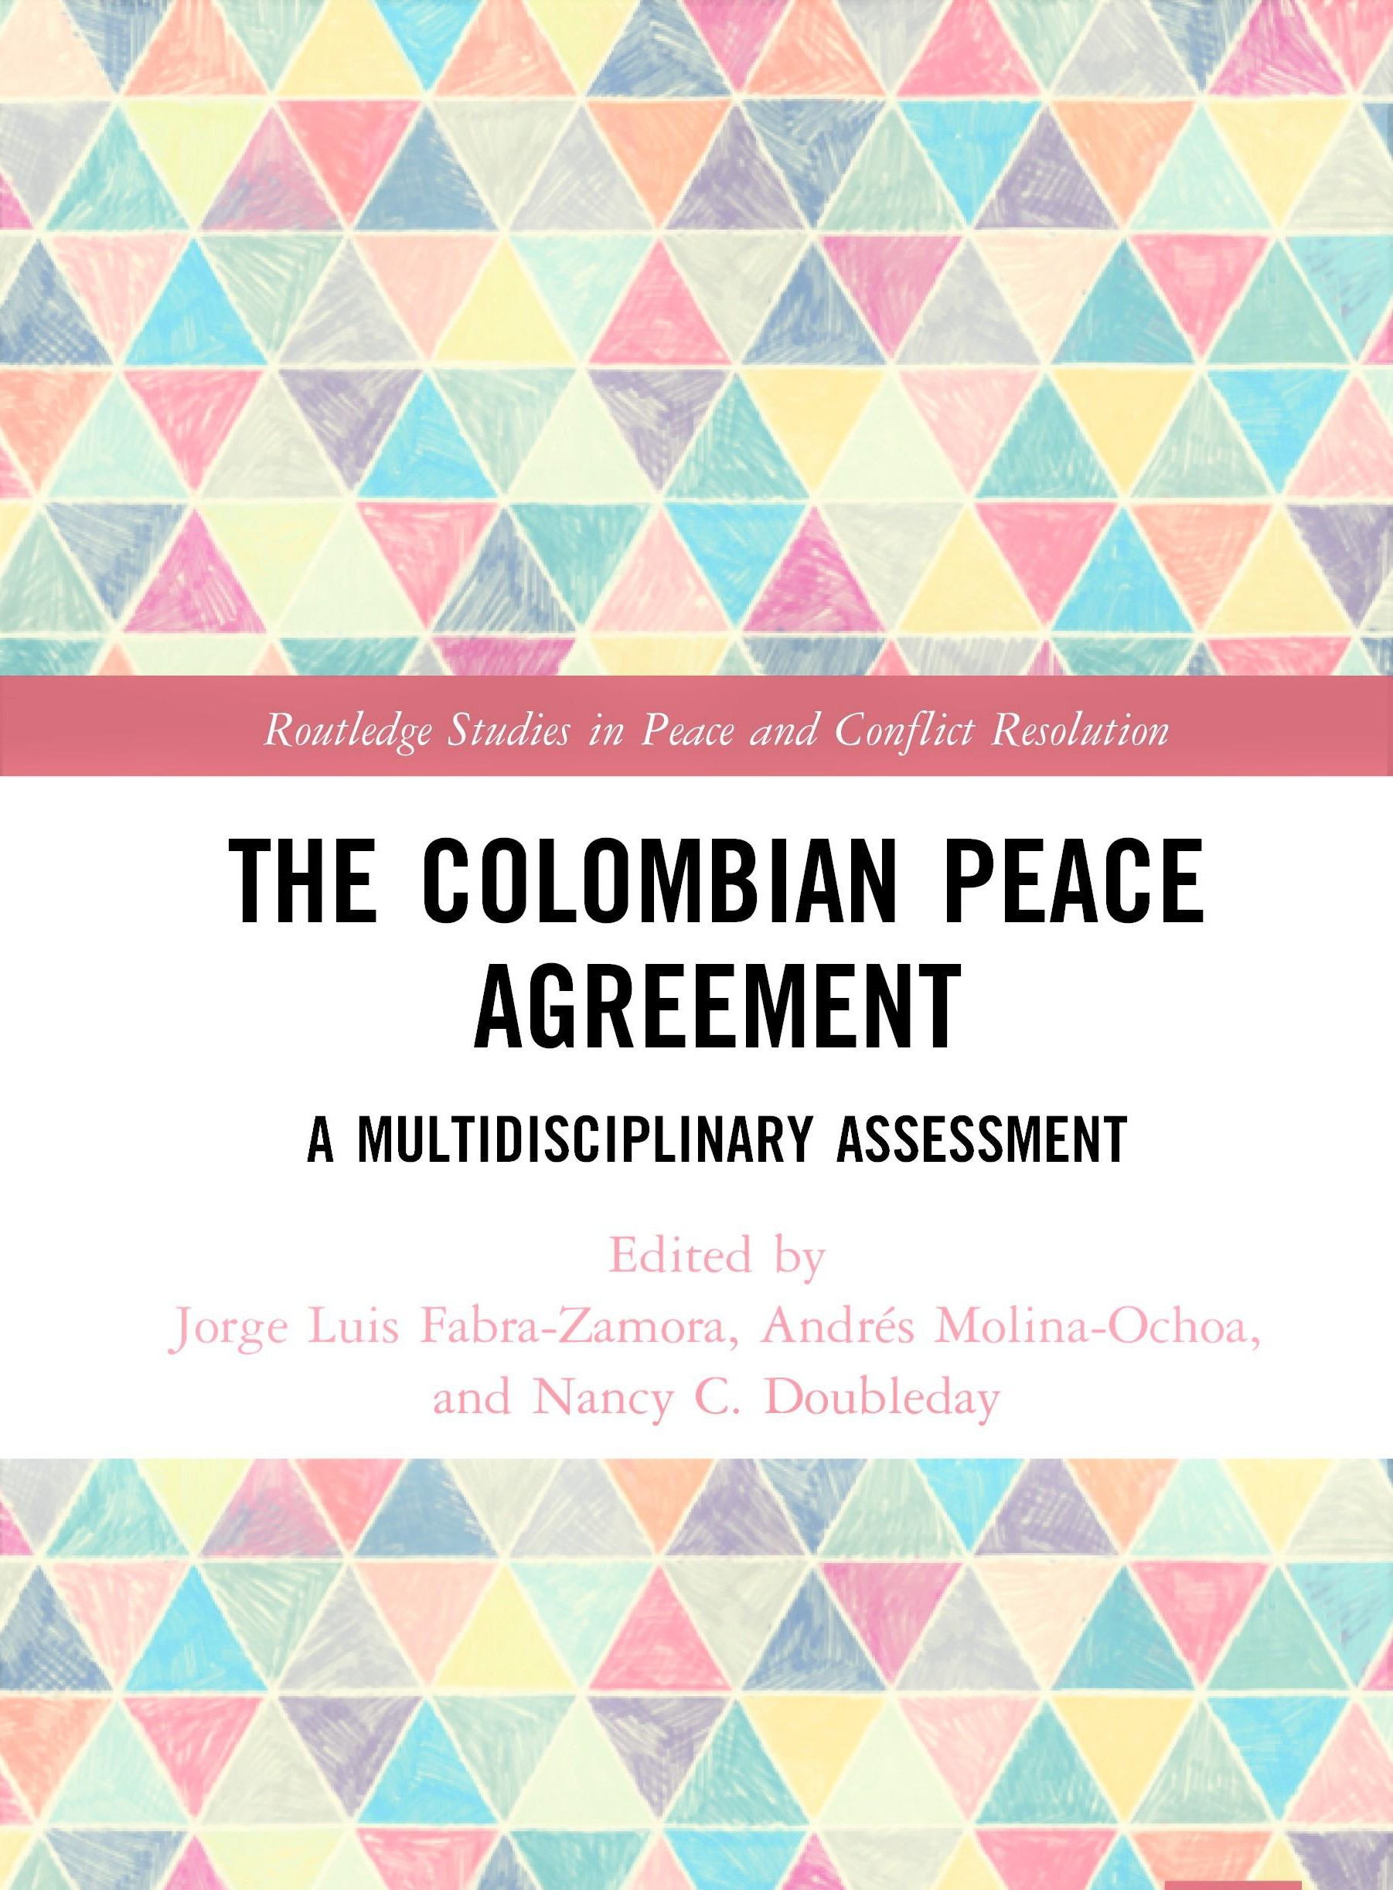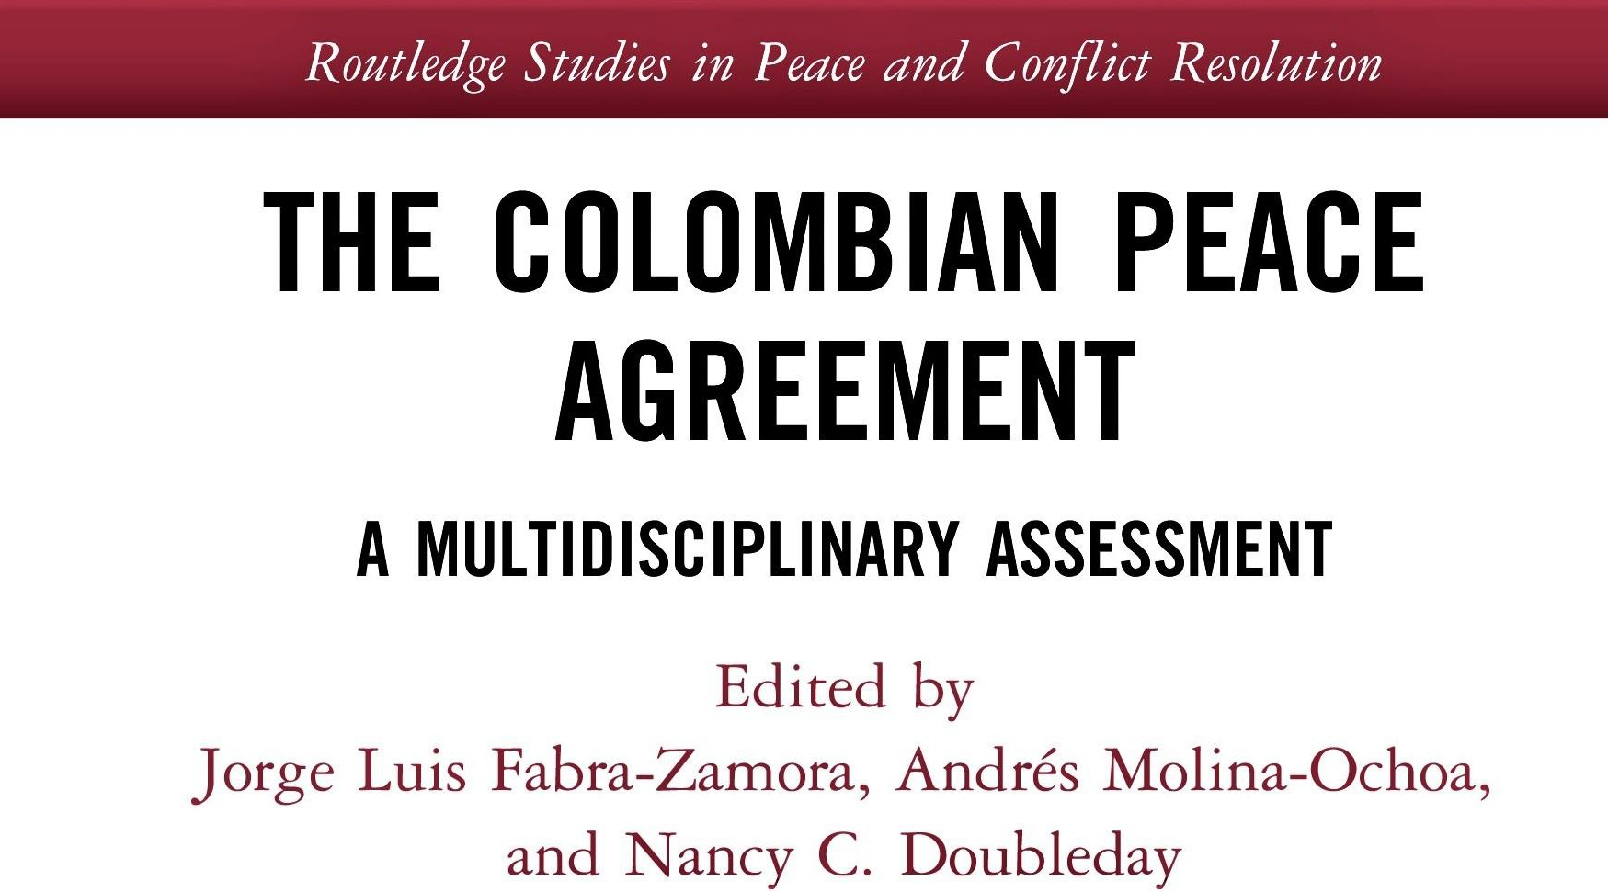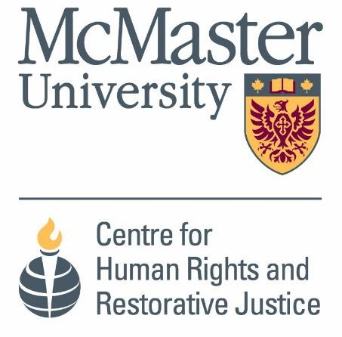

**Jorge Luis Fabra-Zamora**, *University of Toronto* **Andrés Molina Ochoa**, *South Texas College* **Nancy Doubleday,** *McMaster University*

**Information and Registration:** [***bit.ly/colombianpeace***](http://bit.ly/colombianpeace)

The event will be simultaneously translated to Spanish

***El evento tendrá interpretación simúltanea a español***

**June 18, 2021**

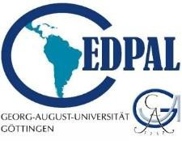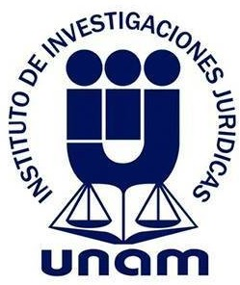**13:00-15:00 (EST) | 12:00-14:00 (Bogota)**

