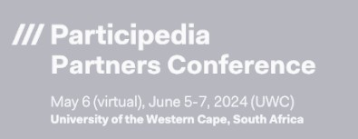

**Hybrid Panel Event & Book Discussion:**

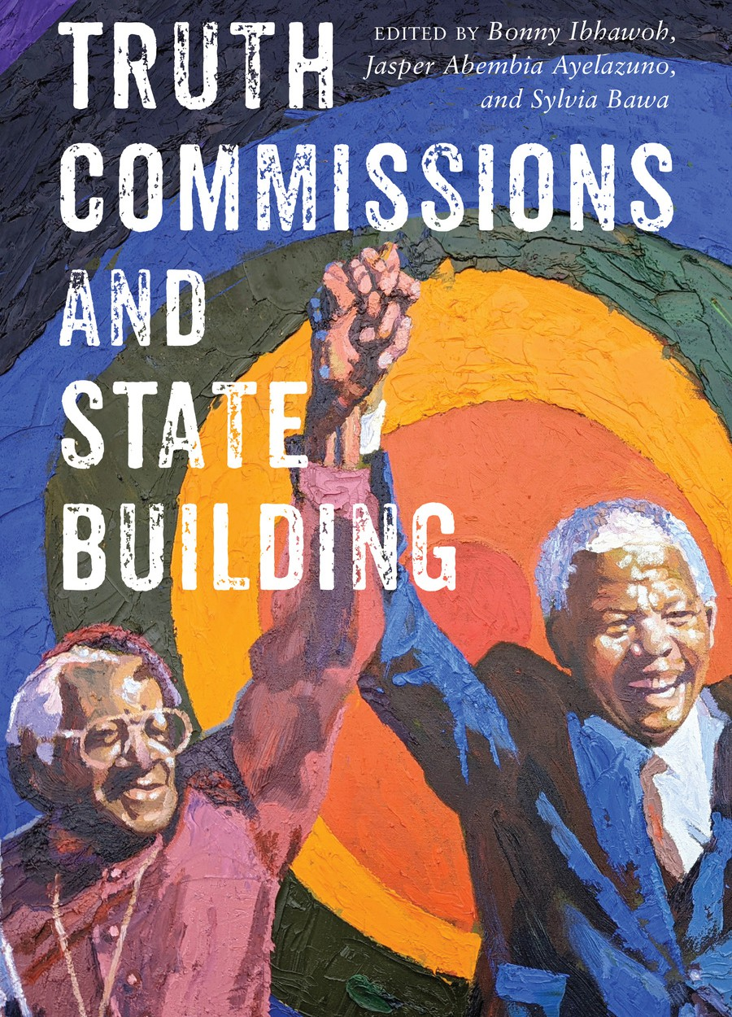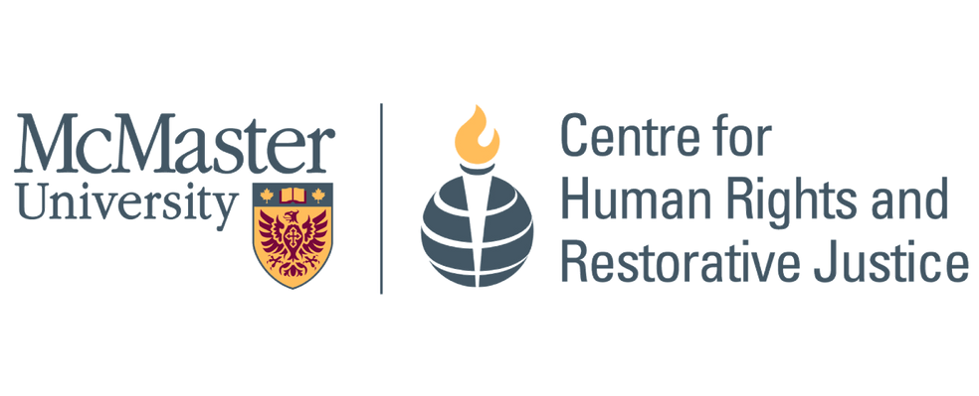

***Truth Commissions and State Building* emerged from a series of conferences organized by the Centre for Human Rights and Restorative Justice (CHRRJ). Chapters of the book draw on data from the Participedia Project and the Truth Commissions Report Database of the Confronting Atrocity Project, which is housed in CHRRJ.**

**“Democracy and the Legacies of Truth and Reconciliation”**

Panelists

Dr. Bonny Ibhawoh (McMaster University, Canada),

Dr. Serges Kamga (University of the Free State, South Africa) and

Dr. Jasper Ayelazuno (University of Development Studies, Ghana)

Moderator

Dr. Fiona Anciano (University of Western Cape, South Africa)

Details Thursday, June 6, 2024

6.00 – 8.00 PM SAST

12.00 – 2.00 PM Toronto Time

[**Click for Online or In-person**](https://www.eventbrite.ca/e/democracy-and-the-legacies-of-truth-and-reconciliation-tickets-885740592957?aff=oddtdtcreator)[**Registration**](https://www.eventbrite.ca/e/democracy-and-the-legacies-of-truth-and-reconciliation-tickets-885740592957?aff=oddtdtcreator)