. . . . . . . .

. • . • • •

. ..

. •. • • . •

* • .. . .

. • • •

* • • • .

Presentations:

# Police out of Care Work

Across Canada we have seen the response to inequity include an increase in policing. We've seen this trend in encampments, in the ways doctors and city workers, police disabled people and their right to exist in public spaces. When police masquerade as care workers, when we rely on security and police to manage our carceral systems, and our healthcare systems, we create the condition where only the wealthy, healthy and housed are deemed as lives worth saving. To change this, we need to take police out of carework.

# Sarah Jama, Disability Justice Network of Ontario

**Refusing colonial eugenics rationalities in mental health policy, practice, and law**

This paper explores contemporary examples of the continued reliance on colonial eugenic rationalities within policy and practice that continue to scaffold and permit carceral and penal violence through the confluence of mental health, criminal justice and immigration policy, practice, and law. The examples of surveillance, confinement, isolation, starvation, and physical violence are explored for their public discursive and policy forebears.

# Ameil Joseph, Associate Professor, School of Social Work McMaster University

**Value(s)**

Thinking beyond punishment, thinking beyond imprisonment means we must think newly yet about how to live better together. In this paper I will argue for a social welfare system that can do more than hold people in poverty. Drawing from Black experiences of previous social welfare calamities I will suggest that the task ahead of all of us is one that urgently requires reinventing our collective social arrangements and that doing so will not only save people, but also save all of our planetary life too.

# Professor Rinaldo Walcott, Women and Gender Studies Institute, University of Toronto

...

# Event Description:

Recent attentions to systemic racism within criminal justice systems including courts, policing, prison systems and surveillance technologies have convened a confluence of analyses, positions of and on the penal and carceral logics that have been historically rationalized and contemporarily mobilized to authorized force, violence, confinement, and persecution in response to perceived criminality.

Many have highlighted the dangers, costs, and disproportionate injustice experienced via designed technologies of adversarial, juridical, colonial policing for Black, First Nations, Metis and Inuit people, people with disabilities, those living with or experiencing mental crises or distress, people struggling with substance use concerns, those living in poverty, those who are underhoused, or houseless, sex workers, as well as those experiencing gender-based or sexual violence.

While analyses of addressing these issues through the allocation of public resources to services, programs, education, healthcare, housing, and income support are well established, there continues to be widespread misunderstanding and/or fear of demands to defund, abolish, or reallocate resources from penal and carceral systems.

In this panel, we aim to engage these issues with a specific attention to

McMaster I Centre for

University -• Human Rights and

**i'** Restorative Justice

HAMILTON- . **CENTRE** •• **FOR CIVIC** *::*

**INCLUSION e•**

.

•

**ISABILITY JUSTICE NETWORK** of ONTARIO

alternatives to penal and carceral, criminalizing logics to respond to social needs.

**BRIGHTER WORLD I mcmaster.ca**

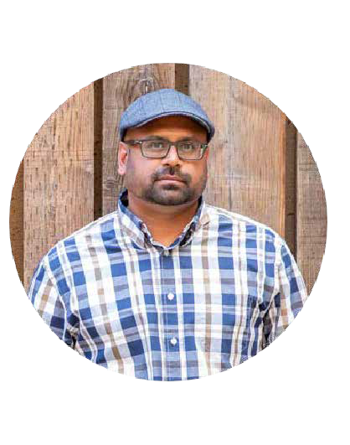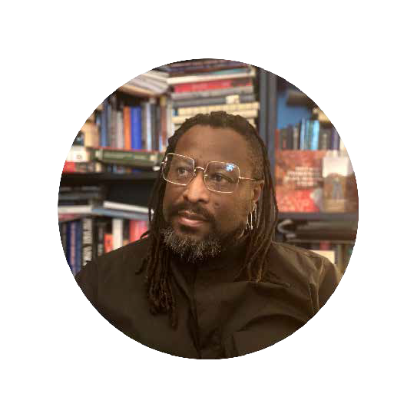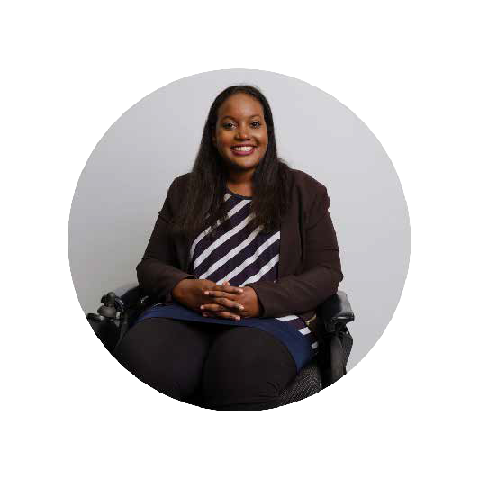

**Register online at: bit.ly/beyondpenal**

The first SO registrants will be able to receive a free copy of Professor Walcott's book, **On Property!**