CALL FOR PAPERS

Truth Commissions: Issues of Access and Ownership

24 - 25 October 2022

Location: Virtual Conference

Date: October 24 - 25, 2022

Abstract Deadline: May 30, 2022

Review of Abstracts: June 30, 2022

Paper Submission: August 30, 2022

This conference aims to bring together expert scholars, policymakers, and civil society stakeholders to examine access to and ownership of Truth Commissions’ (TCs’) documentation. As temporary bodies established to investigate atrocities committed against civilian populations, truth commissions have been deployed for national dialogue, reconciliation and peaceful co-existence in societies torn apart by egregious violence and collective trauma. They have become popular mechanisms for investigating and documenting gross human rights violations and historical atrocities in post-conflict societies. Since the 1990s, over fifty truth commissions have been established worldwide. TCs aspire to create safe, non-partisan and compassionate spaces for both victims and perpetrators to tell their experiences of the human rights violations. For the victims of atrocities, this space grants them a voice and recognition of their victimhood. For perpetrators, the space is of social and therapeutic value, too, through confessional narratives that allow them to tell their truths as part of a more comprehensive process of national healing and reconciliation.

The narratives shared in these TC spaces generate various documents such as written statements, personal interviews, live public testimonies of witnesses and video clips upon which the TCs final reports are based. For the victims, the TC documentation is further proof that their suffering will not be forgotten and provides a basis upon which reparations can be paid. For the perpetrators, the documentation can be an educative tool to prevent future human rights violations and regression to conflict. For the documented societies, this documentation can be democratized to promote public dialogue, reconciliation, and knowledge production to create a culture that builds on respect for human rights.

Despite investments in TCs, the challenges of access to and ownership of the documentation are omnipresent. TCs have taken place in contexts with lack of freedom of information legislation, weak political will to make the documentation available to the citizens, lack of information management institutions, lack of information management and recordkeeping skills and lack of robust information management infrastructures to effectively manage documentation. These challenges often hinder access to the TCs documentation and limit the transformative potential in the documented societies. Documentation is of crucial importance to the transitional justice processes. It should be made accessible to the documented societies to enable the citizens to engage their governments about implementing the TCs recommendations, challenge impunity, promote human rights, deliver justice to victims and foster reconciliation. Therefore, the documents should be preserved and made available in a meaningful way to the communities of principal concern.

**The conference’s objectives:**

1. To explore issues related to access of the TCs documentation.
2. To investigate the obstacles that have prevented the implementation of information infrastructures that should promote access.
3. To address issues of ownership of the TCs documentation.

We are seeking proposals that will explore the following sub-topics: Access regimes and information security

Integration of the TCs’ findings in Education Documentation and Transitional justice Archives and reconciliation Data/Information sovereignty/Ownership Data/digital divides

Information Management/Recordkeeping Information Management Infrastructures Decolonization of the Archives Information ethics

Democracy and information

Indigenous ontologies applied to access, preservation, discovery, and use Orality, digital records, and social memory

Other related topics on the theme

# CONVENERS:

Dr. Proscovia Svärd – Mid-Sweden University, Sweden Dr. Bonny Ibhawoh – McMaster University, Canada

Mr. Raymond Frogner – National Centre for Truth and Reconciliation, Canada

Dr. Melike Yilmaz – McMaster University, Canada Dr. Cyril Obi - Social Science Research Council, USA

Ms. Razia Saleh - Nelson Mandela Foundation, South Africa

# ORGANIZERS:

Mid-Sweden, University, Sweden McMaster University, Hamilton, Canada

National Centre for Truth and Reconciliation, University of Manitoba, Canada

The Social Science Research Council’s African Peacebuilding Network Program, USA

The Nelson Mandela Foundation, South Africa

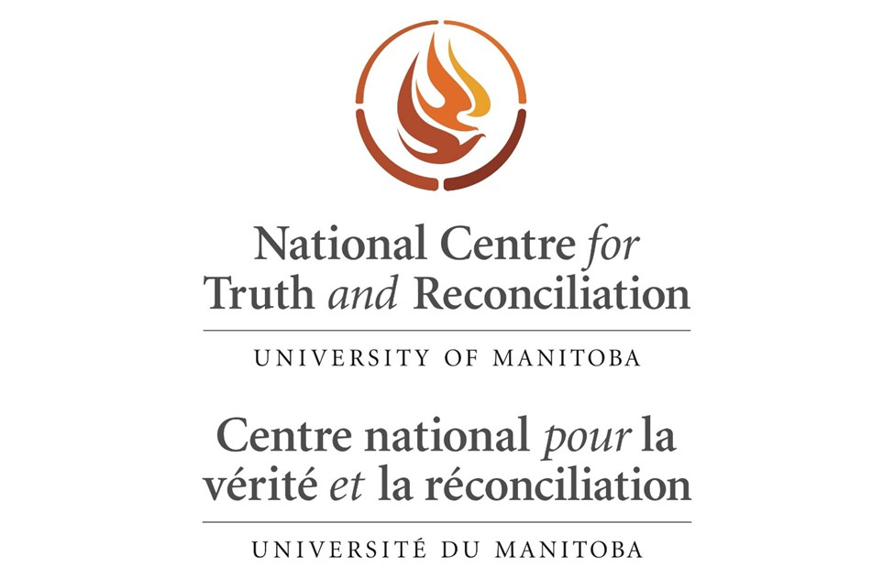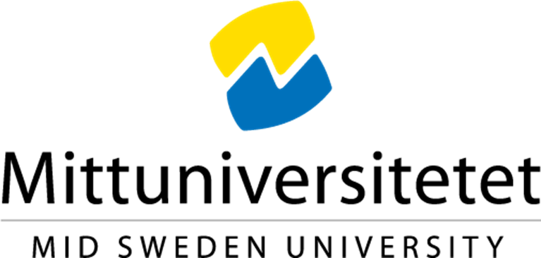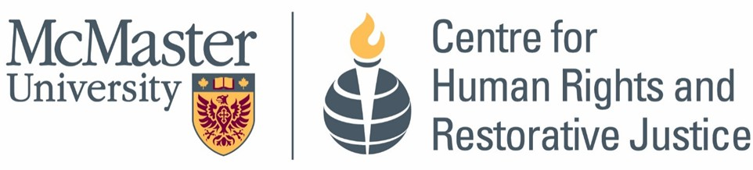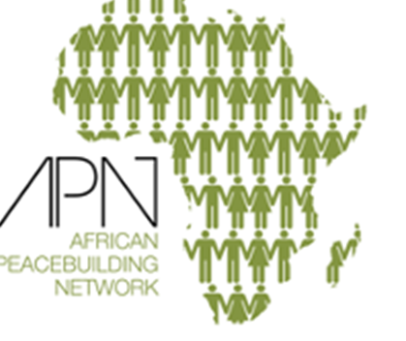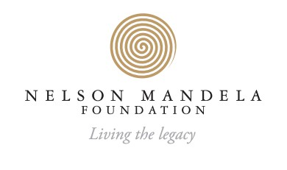

**The conveners will explore publishing opportunities for selected conference presentations.**

**Complete the following Google Form to submit your abstract by May 30, 2022:** [**Abstract Submission Form**](https://docs.google.com/forms/d/e/1FAIpQLSdG326l8GyQA2TuH-HA1HGqvYIqs3e83fYN64L68XKNPTdeig/viewform?usp=sf_link)**.**

**If you are unable to access the form, please send the abstract and bio to:** [**yilmam2@mcmaster.ca**](mailto:yilmam2@mcmaster.ca) **We will notify all submitters of the program committee’s decisions no later than July 6, 2022.**

**For details about the conference, visit the** [**conference website**](https://chrrj.humanities.mcmaster.ca/conferences/)[**.**](https://chrrj.humanities.mcmaster.ca/)

**Contact Information: Dr. Melike Yilmaz (Research Coordinator) -** [**yilmam2@mcmaster.ca**](mailto:yilmam2@mcmaster.ca)